

Mission Report to Pigi Canal County
Agency | Agency for Conservation and Development ACD
Date | Dec 18-29-2024
Location | Koliet, Alam of Pigi Canal County
Project | Save the Elephants
Project Period | Jan 1, 2024 – Dec 31, 2024

Introduction
The communities of Alam and Koliet villages of Pigi County, East of Fangak Game Reserve had since October 2022 sent messages to ACD office over some wildlife protection concerns. Between July and December, 2024, ACD staff and Community Wildlife Ambassadors conducted three missions but could not reach Alam and Koliet due to hinderances posed by floods and thick forests. On December 18, 2024, a team of 12 members led by ACD`s Biometric Officer. The mission included three rangers seven CWAs, and two ACD staff. The objective of the mission was to ascertain presence of elephants, giraffes and lions. The team prepared survey forms aimed at interacting with community members on their relationships with the wild animals. This is the seventh field mission under SS_ACD_04
Wildlife situation
The two villages are being managed through the traditional system of Governance; by chiefs. There is no wildlife management body in place but the community have developed a healthy relationship with the wild animals. A site was shown to the team where a 12-year-old boy was eaten by a wild animals early November 2024. The community reported killing of an elephant and a giraffe in September and October respectively. They said the people killing them were Government soldiers specifically sent from commissioner`s office in Canal. The killing of the wild animals had sparked a rift and the commissioner and his officials were not permitted to visit the two villages. Floods was still very high at the time of visit but the people were optimistic it would recede before April 2025 and were hopeful the elephants and giraffes would return by May. Alam and Koliet are the natural habitats of elephants and giraffes respectively. The two villages are relatively peaceful and far from the national and regional conflicts which further ensure safety of wildlife.
Community collaboration: Protecting wildlife in Greater Fangak
Alam Payam within the wild expanse of greater Fangak's untouched terrain lies within two exceptional conservation treasures: Fangak Game Reserve and Pigi Canal Despite their modest size, these protected areas provide vital habitats for numerous endangered species within their primary forests and vast grasslands and highlands. The Betbet Forest of Alam payam stands as the final significant bastion of unspoiled lowland forest in Greater Fangak, harboring generally significant populations of Lions, Leopards, Giraffes, Monkey, and elephants.
Navigating a range of challenges, from political instability to logistical hurdles, ACD has been instrumental in safeguarding these areas for over a decade against the looming threats of exploitation, particularly from poaching activities.
In response, efforts are underway to collaborate with surrounding communities. ACD selected 15 community members to train as Community Wildlife Ambassadors (CWAs) in January 2024. These will act as a protective force and information gatherers for wildlife and shall be providing a physical barrier between the core reserves and external threats.
Satellite eyes on the land to map biodiversity
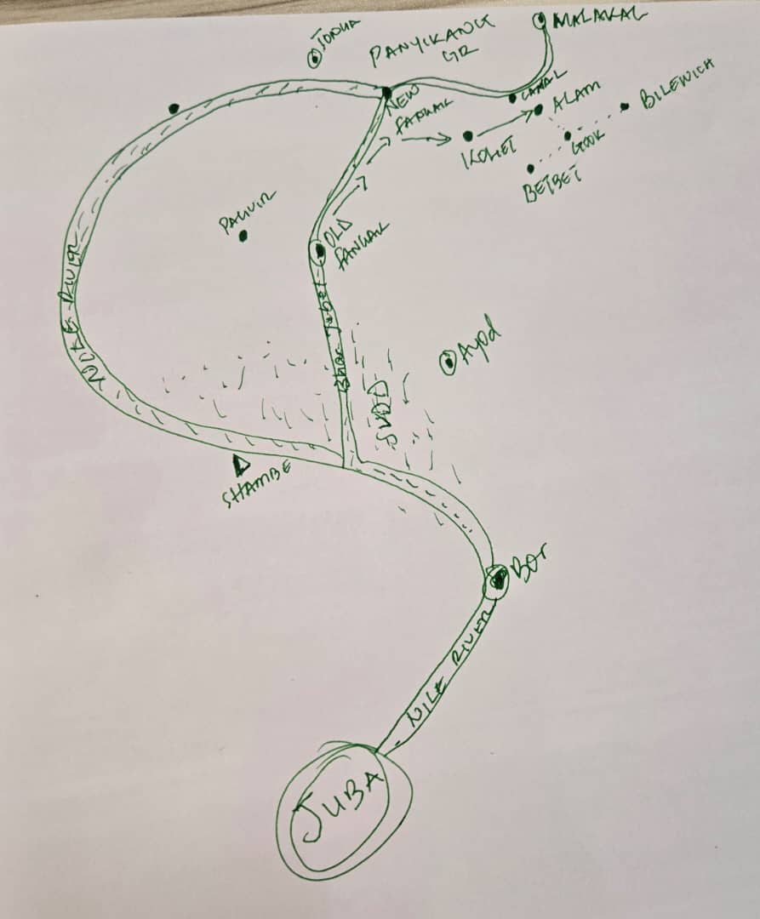
As part of this ambition, ACD is using Camera Traps and Canon Camera funding and technical support from the save the elephants, to conduct a comprehensive landscape-level assessment to map land cover, analyze potential deforestation drivers and evaluate the connectivity of these precious ecosystems.
Through the lens of satellite Camera traps and Canon, ACD's analytics team will unveil intricate details of the habitats and corridors most important to biodiversity living here. Betbet, Gook, and Bilewich was Identify to be the core forest patches and critical connectivity pathways that underpin the survival of countless species and support the CWAs.
Translating data into action
Rooted in collaboration with local communities, findings will inform actionable strategies to help the growing human population co-exist with the wildlife, such as supporting communities to adopt natural resource management practices that improve their livelihoods while supporting conservation goals.
ACD Technical Team proposed to trained the local communities, Hurters and Local authority on the protective measures in those identity areas
Navigating.
Drawing upon decades of experience in Flood affected areas and conflict-affected regions, the ACD has built up a wealth of trust and resilience in the face of adversity in Greater Fangak. Through partnership with the Ministry of Wildlife Conservation and Tourism and the communities of South Sudan, and it main Donors, Save the Giraffes, Save the elephants ACD endeavors to turn these protected areas into beacons of environmental stewardship and socioeconomic empowerment in the next few years.
Assessment Team
S/No | Name in Full | Position | Contact
1 | Wunuer Gatwech Yak | Bio-metric Officer | 0924441824
2 | Mayiel Top Jock | CWAs Team Leader | 0920641705
3 | Tak Chan Khan | Wildlife personnel | 0928806618
4 | Liom Tap Kulang | CWA | 0927433217
5 | Gatliah Wuol Ruei | CWA | 0926835338
6 | Koak Makuei Jock | CWA | 0928983587
7 | Nhial Kuach Koang | CWA | 0928874937
8 | Kuach Toang Kuach | CWA | 0921638403
9 | Nyuon Wunoah | Wildlife personnel | 0927432315
10 | Mayiel Deng Luok | CWA | -
11 | Mabiel Ruach Biel | Wildlife personnel | 0922176534
12 | Wiak Gony Yuot | Boat Driver | 0928828403

Camera traps and GPS Coordinate details
Date 26 to 27-12-2024
S/NO | Name of person who set cam trap | Location | Intend target | Date deployed | Date checked | Camera no | 36P | UTM
1 | Mayiel top | betbet | giraffe | 26/12/24 | 27/12/24 | 01 | 09’09.377 | 031’28.458
2 | Mayiel top | Betbet | giraffe | 26/12/24 | 27/12/24 | 02 | 09’09.372 | 031’28.458
3 | Mayiel top | betbet | giraffe | 26/12/24 | 27/12/24 | 03 | 09’09.371 | 031’28.455

Date 24-12-2024 to 25-12-2024
S/NO | Name of person who set the cam trap | Location | Intended target | Date deployed | Date Checked | Camera No | 36P | UTM
1 | Mayiel top | Betbet | Lion | 24/12/24 | 25/12/24 | 01 | 0328182 | 1012824
2 | Tak chan | Betbet | Lion | 24/12/24 | 25/12/24 | 02 | 0328182 | 1012824
3 | Mayiel top | Betbet | Lion | 24/12/24 | 25/12/24 | 03 | 0328190 | 1012855
4 | Mayiel top | Betbet | Leopard | 24/12/24 | 25/12/24 | 04 | 0333461 | 1012383
5 | Mayiel top | Betbet | Leopard | 24/12/24 | 25/12/24 | 05 | 0333484 | 1012401
6 | Tak chan | Betbet | Lion | 24/12/24 | 25/12/24 | 06 | 0333470 | 1012455
7 | Tak chan | Betbet | Lion | 24/12/24 | 25/12/24 | 07 | 0333478 | 1012471
8 | Mayiel Top | Betbet | Lion | 24/12/24 | 25/12/24 | 08 | 0333464 | 1012466

Date 23-12-2024 to 24-12-2024
S/NO | Name of person who set the camera trap | Location | Intend target | Date deployed | Date checked | Camera no | 36P | UTM
1 | Mayiel top | Betbet | Lion | 23/12/24 | 24/12/24 | 01 | 0332964 | 1012743
2 | Mayiel top | Betbet | Lion | 23/12/24 | 24/12/24 | 02 | 0332781 | 1012761
3 | Tak chan | Betbet | Lion | 23/12/24 | 24/12/24 | 03 | 0332768 | 1012762
4 | Mayiel top | Betbet | Lion | 23/12/24 | 24/12/24 | 04 | 0332744 | 1012766
5 | Mayiel top | Betbet | Lion | 23/12/24 | 24/12/24 | 05 | 0332584 | 1012792
6 | Tak chan | Betbet | Lion | 23/12/24 | 24/12/24 | 06 | 0332524 | 1012798
7 | Tak chan | Betbet | Lion | 23/12/24 | 24/12/24 | 07 | 0332556 | 1012885
8 | Tak chan | Betbet | Lion | 23/12/24 | 24/12/24 | 08 | 0333051 | 1013448

Locations visited on the way to Betbet village, Pigi County
S/NO | Location/Villages | Date | 36P | UTM
1 | Wunlueth Payam | 18/12/2024 | 09’16.972 | 031’12.857
2 | Kurwai Payam | 19/12/2024 | 09’14.610 | 031’10.941
3 | Atar Boma | 20/12/2024 | 09’19.764 | 031’27.622
4 | Alam payam | 21/12/2024 | 09’15.663 | 031’31.628
5 | Koliet Boma | 22/12/2024 | 09’09.505 | 031.28.873
6 | Kokjak village | 22/12/2024 | 09’09.502 | 031’29.094
7 | Betbet Village | 23/12/2024 | 09’09.578 | 031’28.826

Humna-wildlife conflicts and challenges.
- Fighting over small dry spots. The lions, cheetahs, hyenas, and other wild cats are very many in the two villages but the habitat has shrunk.
- Heavy floods have destroyed livelihoods, limited living space, hinder travels, increase conflicts over resources.
- Tree cutting and bush burning. People felt trees for charcoal and clearing for growing crops, while the traditional system of burning bushes rages on in the swamps. This is killing and displacing many wild animals.
- Lack of information on future benefits and the importance of wildlife; tourism, markets and town development, water catchment, change of weather, etc
- Absence of Government and wildlife protection body
- Animals are eating people in Betbet village. ACD Team registered a case of 12 Years Old Boy eaten on the 12/Nov/ 2024 at around 9:57pm.
The child was sleeping together with two other 2 kids in a tent.
Name of the late son
Kom Maduk Puor, 12 Years Old
GPS 36P 09’09.275 UTM 031’30.010
Name of the late son`s Father
Maduk Puor Tuthiang
Tel No: 0920947333

